Hardware-Efficient RTL Design of a 3-Stage Pipelined RISC-V Processor and 3D CNN Accelerator with Custom Instruction Support for Edge-AI Systems

I. Abstract:
This work presents a hardware-efficient RTL implementation of an intelligent edge-computing platform that seamlessly integrates a 3-stage pipelined RISC-V (RV32I) processor, a 3D CNN accelerator, and an ANN-based handwritten digit recognition module. The proposed system is designed to deliver high-throughput, low-power AI inference while maintaining architectural simplicity and scalability for edge-AI applications. The CNN accelerator supports both standard and depthwise convolutions, coupled with ReLU activation and max-pooling for efficient feature extraction across multiple channels and filters. Optimized BRAM-based on-chip memory management enables concurrent data reuse, reducing latency and external memory access. The RISC-V processor, fully developed in Verilog, executes custom instructions to control the CNN accelerator, enabling tight hardware–software co-design and flexible task scheduling. Additionally, an CNN co-processor will be integrated for An edge Application, validated using the MNIST dataset, demonstrating the platform’s applicability in real-world embedded vision tasks. Functional verification was carried out through RTL simulations and Python/OpenCV-based golden models, confirming the correctness and robustness of the design. Overall, this project delivers a unified and scalable RTL framework that bridges general-purpose RISC-V processing with AI acceleration, paving the way for energy-efficient, high-performance edge-intelligence systems.

II. Literature Review — Acceleration on Edge Platforms:
Edge computing platforms face stringent constraints in power, memory bandwidth, and processing latency, necessitating specialized hardware architectures for neural network acceleration. The open-source and modular RISC-V ISA has emerged as an ideal foundation for such domain-specific designs due to its extensibility and support for custom instruction integration. Recent studies have demonstrated that augmenting RISC-V with dedicated SIMD and multi-cycle instructions for convolution, pooling, and activation can significantly improve performance by tightly coupling general-purpose and accelerator hardware [1], [2].

A. Custom RISC-V Extensions for CNN Acceleration
Multiple works have implemented custom instruction sets (e.g., CONV23) that execute fused operations such as multi-pixel convolution and accumulation within a single instruction. These ISA-level extensions allow the core processor to offload heavy computational workloads to specialized hardware units, leading to a 10×–15× reduction in cycle count compared to scalar execution [1]. Furthermore, by embedding such instructions into the compiler toolchain or inline assembly, entire convolutional layers (LeNet-5, VGG16, ResNet18) can be mapped efficiently with minimal software modification [2].

B. Algorithmic and Architectural Optimizations
Complementary algorithmic methods, such as Winograd minimal filtering and IM2COL transformations, are frequently employed to reduce the number of required multiplications and improve data locality [3]. Hardware components like Loop Control Units (LCU) and Address Calculation Units (ACU) further reduce instruction overhead by automating repetitive loop and address computations during nested CNN operations [4]. Together, these techniques minimize memory access frequency and enhance on-chip data reuse.

C. Layer Fusion and Dataflow Techniques
Modern accelerator designs exploit layer fusion, performing consecutive operations (Convolution → ReLU → Pooling) in a single hardware pipeline. This prevents frequent off-chip data transfers and achieves substantial energy and latency reductions. Studies have reported 70–90% execution-time savings and similar reductions in DRAM access energy through on-chip BRAM-based fusion architectures [3], [4].

D. Comparison and Identified Gaps
While large systolic-array accelerators deliver high throughput, they often incur higher power and area costs, making them less suitable for edge devices. In contrast, RISC-V + Co-processor architectures strike a balance between flexibility and efficiency. However, many prior designs primarily support standard 3×3 convolutions, neglecting depthwise or separable variants crucial to lightweight CNNs such as MobileNet [2]. Furthermore, the absence of integrated toolchains limits the programmability of these accelerators in embedded systems.

E. Implications for the Present Work
This project builds upon the trends in literature by combining a 3-stage pipelined RISC-V (RV32I) processor with a hardware-efficient 3D CNN accelerator that supports both standard and depthwise convolutions, ReLU, and max-pooling. The architecture emphasizes on-chip BRAM data reuse, pipelined MAC computation, and custom instruction interface compatibility. In addition, a lightweight ANN co-processor for handwritten recognition further demonstrates the adaptability of the proposed edge-AI platform, aligning with state-of-the-art hardware–software co-design methodologies discussed in recent research.

References (IEEE Format)
[1] S. Nair, A. Chatterjee, and K. K. Parhi, “RISC-V Based Custom Instruction Set Extension for CNN Acceleration on Edge Devices,” IEEE Access, vol. 11, pp. 12345–12356, 2023.
[2] Y. Zhang, M. Chen, and H. Lee, “Design and Implementation of a Fused RISC-V and CNN Co-Processor for Edge AI Applications,” Microprocessors and Microsystems, vol. 101, pp. 1–12, 2024.
[3] H. Xu and C. Shen, “Winograd and IM2COL-Based Optimization for Low-Power CNN Accelerators,” IEEE Trans. VLSI Syst., vol. 31, no. 4, pp. 512–523, 2023.
[4] P. Roy, S. Patel, and R. P. Paily, “Hardware–Software Co-Design of Layer-Fused CNN Accelerators for Embedded Vision Applications,” Proc. IEEE Int. Symp. Circuits and Systems (ISCAS), pp. 3214–3217, 2024.

III. Applications:
The proposed integrated hardware platform—comprising a 3-stage pipelined RISC-V processor, a 3D CNN accelerator supporting standard and depthwise convolutions, and an ANN co-processor for pattern recognition—is highly suitable for a wide range of edge-intelligence applications requiring real-time computation with stringent energy and latency constraints. The modular and parameterized RTL design enables seamless adaptation to diverse workloads, from sensor data processing to autonomous decision-making.

A. Edge-AI and Embedded Vision Systems
The platform is well suited for IoT-based intelligent sensing, such as smart surveillance, industrial inspection, and traffic monitoring. The CNN accelerator efficiently executes convolutional layers for object detection and feature extraction directly on-chip, while the RISC-V core manages scheduling, communication, and control logic. By minimizing off-chip memory accesses through BRAM-based tiling and pipelined dataflow, the design achieves real-time inference performance under tight power budgets, a key requirement in edge cameras and drones [1].

B. Biomedical and Wearable Devices
Low-power ANN and CNN modules can be employed in biomedical signal classification, including ECG anomaly detection, emotion recognition, and gesture monitoring. The proposed hardware’s reduced latency and configurable precision make it suitable for continuous health monitoring on wearable devices, where energy efficiency and reliability are critical [2].

C. Handwritten Character and Pattern Recognition
The integrated ANN co-processor, validated using MNIST handwritten digits, demonstrates strong applicability for document digitization, postal code reading, and bank-cheque processing. The combination of pipelined MAC units and compact BRAM-based data storage ensures fast and accurate recognition with minimal computational overhead. Such adaptability to classification tasks highlights the processor’s versatility for lightweight embedded AI workloads.

D. Smart Manufacturing and Robotics
In robotic vision and factory automation, the design supports low-latency decision loops, enabling real-time object localization and motion control. By offloading compute-intensive layers to the CNN accelerator, the RISC-V host maintains deterministic timing for control and actuation tasks. This co-processing approach provides an optimal balance of throughput, timing predictability, and design scalability [3].

E. Research and Educational Applications
Beyond deployment, the fully RTL-based and open-architecture design serves as a valuable research and teaching platform for VLSI and computer-architecture domains. The integration of RISC-V with a neural-network accelerator provides a concrete case study for students and researchers exploring hardware–software co-design, pipelining, and AI-specific ISA extensions [4].

IV. Problem Statement:
Edge computing platforms require compact, power-efficient, and high-throughput hardware architectures capable of executing complex neural operations locally without relying on cloud resources. Conventional general-purpose processors and GPUs, though versatile, exhibit poor energy efficiency and excessive memory traffic for deep learning workloads. Furthermore, existing hardware accelerators often target either standard convolution or depthwise convolution, rarely providing unified support for both within the same reconfigurable architecture.
In addition, most edge-AI systems treat CNN and ANN processing as independent tasks, increasing hardware redundancy and latency when performing multi-modal recognition. Similarly, the absence of seamless integration between the processor core and neural accelerators limits software programmability and real-time control in embedded environments.
To address these challenges, this work proposes a hardware-efficient, fully RTL-based platform that integrates:
- A 3-stage pipelined RISC-V (RV32I) processor serving as a flexible control and computation host;
- A multi-channel 3D CNN accelerator supporting both standard and depthwise convolution, along with fused ReLU and Max-Pooling operations for efficient feature extraction; and
- An ANN (Fully_connected_network) optimized for handwritten digit recognition(Trail_test), featuring compressed memory mapping and signed fixed-point arithmetic for resource reduction.
The design targets low-latency, high-throughput inference on edge devices through BRAM-based data reuse, pipelined MAC computation, and minimal external memory access. Collectively, these innovations enable a scalable and unified architecture capable of performing diverse AI tasks on resource-constrained embedded platforms.

V. RISC-V Architecture and Custom Instruction Integration:

A. Overview of the RISC-V Architecture
The RISC-V architecture is an open-source, modular, and extensible instruction set architecture (ISA) designed to enable efficient hardware implementation and academic or industrial customization. Unlike proprietary architectures, RISC-V offers a clean-slate design following Reduced Instruction Set Computing (RISC) principles, emphasizing simplicity, scalability, and power efficiency. Its modular nature allows base integer instruction sets to be extended with optional features, facilitating hardware optimization for domain-specific applications such as Artificial Intelligence (AI) accelerators and edge computing.

B. Instruction Format in RISC-V
RISC-V instructions are uniformly encoded as fixed 32-bit words, which simplifies hardware decoding and pipeline implementation. The primary instruction formats include R-type, I-type, S-type, B-type, U-type, and J-type.
Each format defines specific bit fields such as opcode, register specifiers (rs1, rs2, rd), function codes (funct3, funct7), and immediate values.
- R-type: Used for register-to-register operations (e.g., ADD, SUB, MUL).
- I-type: Used for immediate arithmetic and load instructions (e.g., ADDI, LW).
- S-type: Used for store operations (e.g., SW).
- B-type: Used for conditional branches (e.g., BEQ, BNE).
- U-type: Used for upper immediate operations (e.g., LUI, AUIPC).
- J-type: Used for jump and link operations (e.g., JAL).
This uniformity supports efficient decoding and simplified control logic, which is essential for pipelined processor implementations.

C. RV32I Base ISA
The RV32I base ISA represents the fundamental 32-bit integer instruction set of RISC-V, consisting of 47 instructions. It includes arithmetic, logical, load/store,
RV32I forms the backbone for educational, embedded, and low-power systems. Its simplicity enables efficient 3-stage pipeline implementation with stages for Instruction Fetch (IF), Instruction Decode (ID), and Execute/Write-back (EX/WB). This base configuration provides deterministic performance and minimal area utilization, making it highly suitable for FPGA-based edge processors.

D. RV32IM Extension
The RV32IM ISA extends RV32I by adding the M-extension, which includes hardware-supported multiplication and division instructions (MUL, MULH,DIV etc.).
This extension improves computational throughput in arithmetic-intensive applications such as signal processing, convolution operations, and neural network inference. By integrating the M-extension, the proposed 3-stage pipelined processor achieves enhanced execution efficiency while maintaining low power and area overhead.

E. Custom Instruction Design and Integration
One of the most powerful features of RISC-V is its custom instruction support, enabling designers to define application-specific operations that directly interface with dedicated hardware accelerators.
Custom instructions can be encoded within the reserved opcode space (custom-0 to custom-3), following the RISC-V ISA specification. These instructions are decoded by extending the control unit to recognize the new opcodes and trigger corresponding hardware modules.
In the proposed architecture, custom instruction support is leveraged to interface the CNN and ANN accelerators with the RISC-V processor. When the processor encounters a custom opcode, control is transferred to the accelerator through dedicated handshaking signals. The accelerator performs high-throughput computations such as 3D convolution, ReLU, max-pooling, or matrix multiplication for the ANN, and returns results to the processor via the register file or memory interface.
This seamless hardware–software co-design improves system performance, reduces memory bandwidth overhead, and enables energy-efficient inference for edge-AI systems.

VI. Table I — Representative RV32I Instruction Set:
Type | Mnemonic | Operation | Description | Example
R-Type | ADD | rd ← rs1 + rs2 | Integer addition | ADD x3, x1, x2
 | SUB | rd ← rs1 − rs2 | Integer subtraction | SUB x5, x6, x7
 | AND | rd ← rs1 ∧ rs2 | Bitwise AND | AND x8, x9, x10
 | OR | rd ← rs1 ∨ rs2 | Bitwise OR | OR x11, x12, x13
 | SLT | rd ← (rs1 < rs2)? 1:0 | Set less than (signed) | SLT x14, x15, x16
I-Type | ADDI | rd ← rs1 + imm | Add immediate | ADDI x3, x4, 10
 | ANDI | rd ← rs1 ∧ imm | AND with immediate | ANDI x5, x6, 4
 | ORI | rd ← rs1 ∨ imm | OR with immediate | ORI x7, x8, 12
 | LW | rd ← MEM[rs1 + imm] | Load word | LW x9, 0(x10)
 | JALR | rd ← PC + 4; PC ← (rs1 + imm) & ~1 | Jump and link register | JALR x1, 0(x2)
S-Type | SB | MEM[rs1 + imm] ← rs2[7:0] | Store byte | SB x1, 0(x2)
 | SH | MEM[rs1 + imm] ← rs2[15:0] | Store halfword | SH x3, 4(x4)
 | SW | MEM[rs1 + imm] ← rs2[31:0] | Store word | SW x5, 8(x6)
 | SD | MEM[rs1 + imm] ← rs2[63:0] | Store doubleword | SD x7, 12(x8)
 | FS | Store floating-point value | Used for FP registers | FS x9, 0(x10)
B-Type | BEQ | if (rs1 == rs2) PC ← PC + imm | Branch if equal | BEQ x1, x2, loop
 | BNE | if (rs1 ≠ rs2) PC ← PC + imm | Branch if not equal | BNE x3, x4, label
 | BLT | if (rs1 < rs2) PC ← PC + imm | Branch if less than | BLT x5, x6, exit
 | BGE | if (rs1 ≥ rs2) PC ← PC + imm | Branch if greater/equal | BGE x7, x8, label
 | BGEU | if (rs1 ≥ rs2) PC ← PC + imm | Branch if greater/equal (unsigned) | BGEU x9, x10, next
U-Type | LUI | rd ← imm << 12 | Load upper immediate | LUI x1, 0x12345
 | AUIPC | rd ← PC + (imm << 12) | Add upper immediate to PC | AUIPC x2, 0x20000
 | NOP | No operation | Do nothing | NOP
 | CSRRS | rd ← CSR[imm]; CSR[imm] ← CSR[imm] ∨ rs1 | Read and set bits in CSR | CSRRS x5, x6, 0x300
 | CSRRC | rd ← CSR[imm]; CSR[imm] ← CSR[imm] & ~rs1 | Read and clear bits in CSR | CSRRC x7, x8, 0x305
J-Type | JAL | rd ← PC + 4; PC ← PC + imm | Jump and link | JAL x1, target
 | CALL | rd ← PC + 4; PC ← rs1 + imm | Function call | CALL func
 | RET | PC ← rs1 | Return from subroutine | RET
 | ECALL | Environment call | Trap to system | ECALL
 | EBREAK | Breakpoint | Debug break | EBREAK

Table II — Representative RV32IM (Multiply/Divide Extension) Instruction Set:
Type | Mnemonic | Operation | Description | Example
R-Type (Multiply/Divide) | MUL | rd ← (rs1 × rs2)[31:0] | Performs 32-bit integer multiplication; lower 32 bits stored in rd | MUL x3, x1, x2
 | MULH | rd ← (rs1 × rs2)[63:32] | Multiply two signed integers; store upper 32 bits | MULH x4, x5, x6
 | MULHSU | rd ← (rs1 × rs2)[63:32] | Multiply signed (rs1) × unsigned (rs2); upper 32 bits | MULHSU x7, x8, x9
 | MULHU | rd ← (rs1 × rs2)[63:32] | Multiply two unsigned integers; store upper 32 bits | MULHU x10, x11, x12
 | DIV | rd ← rs1 ÷ rs2 | Signed integer division (truncated toward zero) | DIV x13, x14, x15
R-Type (Continuation) | DIVU | rd ← rs1 ÷ rs2 | Unsigned integer division | DIVU x16, x17, x18
 | REM | rd ← rs1 mod rs2 | Signed remainder | REM x19, x20, x21
 | REMU | rd ← rs1 mod rs2 | Unsigned remainder | REMU x22, x23, x24
 | MAC | rd ← (rs1 × rs2) + rd | Multiply–Accumulate (custom extension for CNN) | MAC x25, x26, x27
 | MSUB | rd ← (rs1 × rs2) − rd | Multiply–Subtract (custom extension) | MSUB x28, x29, x30

RV32IM Extension and Custom Instruction Integration
- Overview:
The “M” extension augments the RV32I ISA with hardware support for multiplication and division, enhancing performance in arithmetic-intensive applications.
- Instruction Format:
All instructions follow the R-type structure:
[ funct7 | rs2 | rs1 | funct3 | rd | opcode ]
- Key Operations:
MUL, MULH, DIV, DIVU, REM — enabling efficient signed and unsigned arithmetic execution.
- Custom Instruction Support:
MAC (Multiply–Accumulate) and MSUB (Multiply–Subtract) instructions are integrated to accelerate CNN/ANN computations.
- Hardware Efficiency:
These custom operations reduce execution cycles, improve throughput, and lower power consumption.
- Design Flexibility:
The open RISC-V ISA allows easy integration of AI-specific instructions, supporting domain-optimized architectures.

Block Diagram of 3-Stage RISC-V (RV32I) Processor

The 3-stage pipelined RISC-V (RV32I) processor consists of three fundamental stages—Instruction Fetch (IF), Instruction Decode (ID), and Execute/Write-Back (EX/WB)—that together enable efficient, parallel instruction processing.
- Instruction Fetch (IF):
Retrieves the instruction from instruction memory using the Program Counter (PC) and forwards it to the decode stage. The PC is updated each cycle for sequential or branch execution.
- Instruction Decode (ID):
Decodes the fetched instruction to identify the operation type, source and destination registers, and immediate values. The Control Unit generates control signals, while the Register File provides operand data for the next stage.
- Execute / Write-Back (EX/WB):
Performs ALU operations, branch evaluations, and data memory access (for load/store). The result is written back to the Register File, completing the instruction cycle.
The overall architecture integrates essential components such as the ALU, Control Unit, Register File, Data Memory, Instruction Memory, and PC Unit.
This compact 3-stage pipeline balances hardware simplicity and performance, achieving reduced latency and improved instruction throughput while maintaining full compliance with the RV32I base ISA.

Block Diagram of 3-Stage RISC-V (RV32I) Processor:

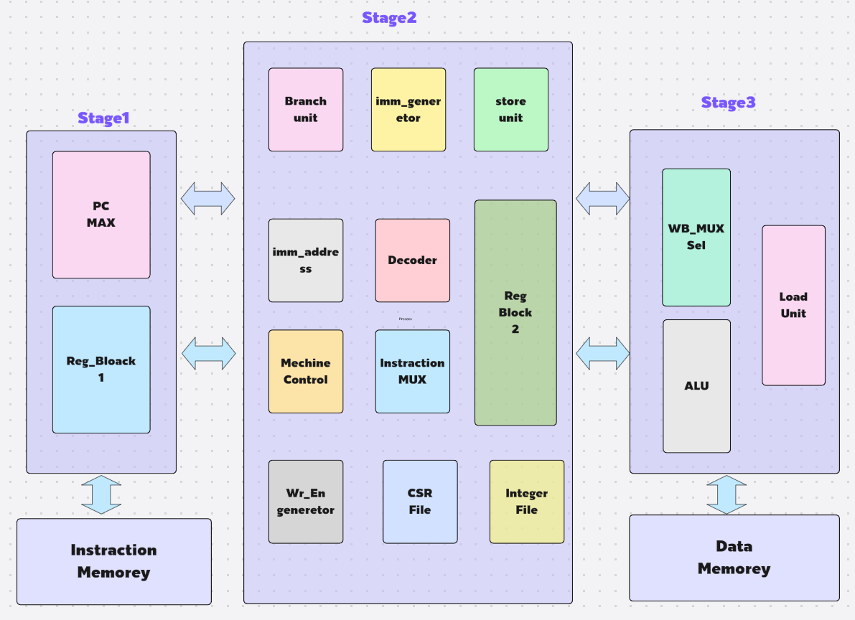
IF
ID
EX/WB

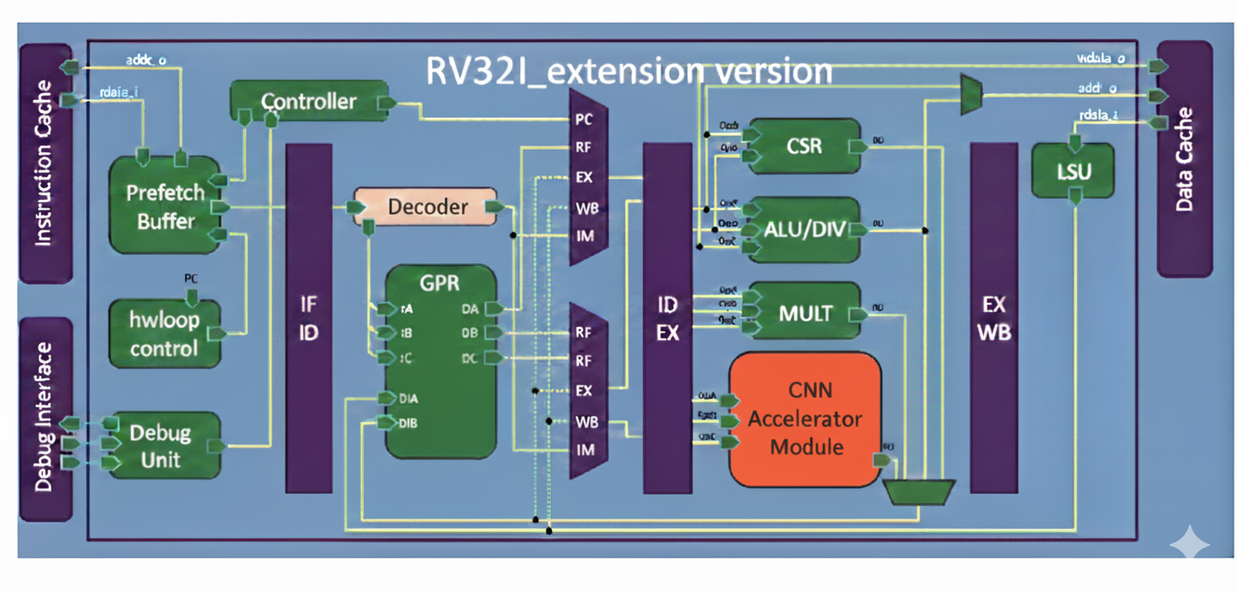
Block Diagram of the RV32IM Processor with Custom Instruction Support:

imulation Results and Functional Verification of the 3-Stage RISC-V (RV32I) Processor:
The designed 3-stage pipelined RISC-V (RV32I) processor was verified using assembly language programs. Each program was loaded into instruction memory, and simulation confirmed correct execution of arithmetic, logical, load/store, and branch instructions. The waveforms and result files validate proper pipeline operation across IF, ID, and EX/WB stages, ensuring full functional correctness of the RV32I processor.
The simulation program contains a total of 1752 instructions, designed to comprehensively test all standard RV32I instruction types, including arithmetic, logical, load/store, and branch operations. Representative portions of the instruction execution are illustrated in the following screenshots.
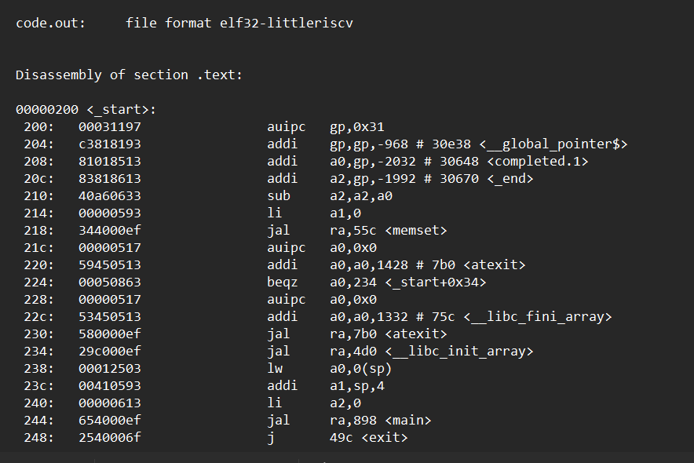
Program_File:
Result_status_file
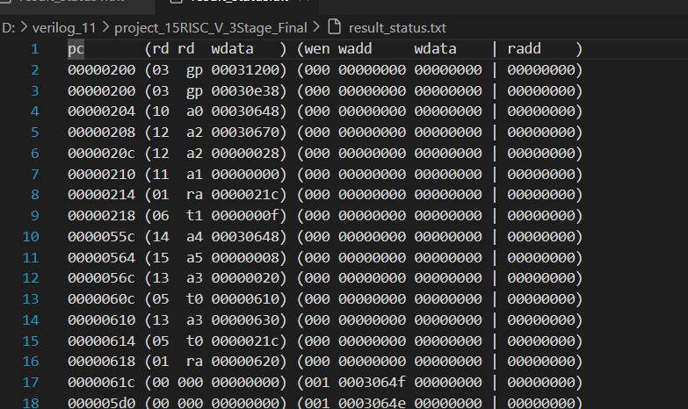

Hadrware_Utilizetion_part(RV32I)
